Predicting Data Science Salaries with Linear Mixed Models
Abstract
This project analyzes a dataset of data science salaries from 2024 to 2025 using a Mixed Linear Regression Model. The study aims to identify the factors that significantly influence employee salaries in the data science field. The results indicate that the most significant factors include experience level, company size, and employee location. These findings provide valuable insights into hiring trends and salary expectations in the data science field. What’s more, the analysis offers a clearer understanding of potential career prospects for individuals planning to work in data science.
- Introduction
The demand for data scientists has grown fast in recent years, making salary prediction and job market analysis more important for companies and employees. Understanding which factors contribute to salary can help applicants, employers, and HR make more informed decisions.
This project aims to investigate how factors such as job title, company size, and industry affect salaries in the data science field. Exploring the relationships among these factors can help employees determine suitable career paths.
In this study, we use the AI Job Market & Salary Analysis 2025 dataset. The key variables include: job_title, salary_usd, salary_currency, experience_level, employment_type, company_location, company_size, employee_residence, remote_ratio, required_skills, education_required, years_experience, industry, and benefits_score.
Especially, this project focuses on the relationship between salary and job-related factors. To achieve the goals, this study will do exploratory data analysis (EDA) and quantify the effects of these factors on salary by a linear mixed-effect model.
- Method
2.1 Data Cleaning Data cleaning and exploratory analysis
This project began with exploratory data analysis (EDA) to investigate salary variation among education levels, job titles, industries, and experience levels. This EDA used distribution plots, box plots, and trend plots to search for patterns and potential outliers.
For data cleaning, we standardized the dataset by converting the posting_date column to Date format and splitting the required_skills column into wide and long formats for EDA. We also created new binary columns such as program, version, bigdata, cloud, deployment, MLprogram, MLknowledge, and math to represent different types of skills. This process aimed to reduce multicollinearity in model.
We used various visualization to reveal the data. Bar plots can analyze counts of skills, and explore the count of job among different education levels and experience levels. Violin plots can examine salary distributions among industries, experience levels, and education levels. Histograms to assess overall salary distribution. Line and point plots to track trends in the top jobs and top skills from 2024 to 2025.
These analyses provided a comprehensive analysis of the data and guided subsequent modeling.
2.2 Linear mixed regression description
To capture salary variations at the group level, such as company location and experience level, we applied a linear mixed-effects model:
$$log(salary)=α_{j[i]}+{βx}_{i}+ε_{i}$$
$$ε_{i}\sim N(0,σ_{y}^{2}){ α}_{j} \sim N(μ_{α},σ_{α}^{2})$$
This study assessed the requirement for random effects using the intraclass correlation coefficient (ICC). Only variables with an ICC greater than 0.1 are accepted as random variable in the model. Model assumptions were examined via residual plot, and error-bar plots of random intercepts.
- Result
3.1 Exploratory Data Analysis
The dataset contains 15,000 AI-related job postings, including information about countries, industries, and experience levels.
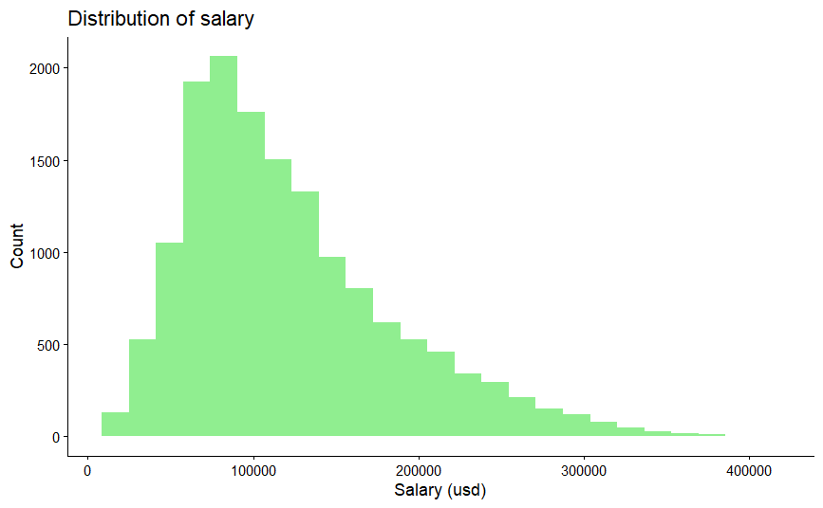
Because the raw salary distribution was strongly right-skewed, we used the log-transformed salary (log(salary_usd)) in the linear mixed model. The summary statistics show that most salaries belong to 80k and 160k dollars. However, a few extreme values approach 400k. dollars. The histogram confirmed this right-skewed pattern, with a high counts in the mid-range and a long tail of higher salaries.
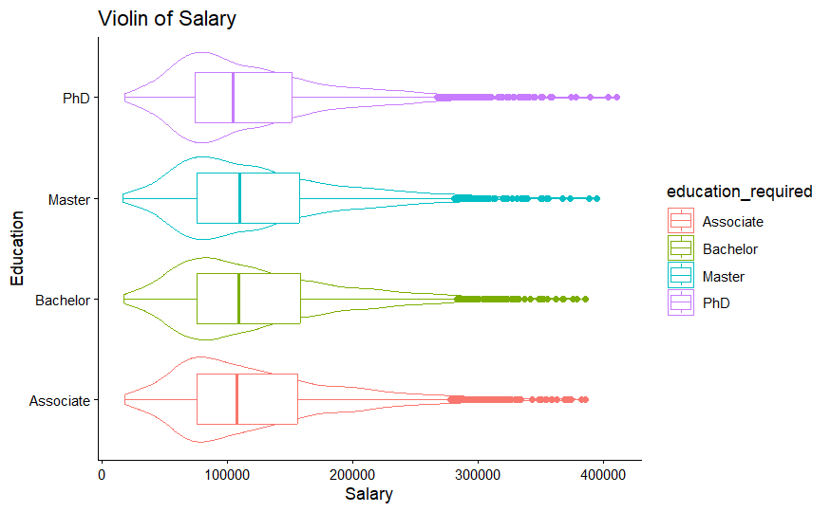
This project used violin plot to compare salary distributions among several groups. The First is the education levels. The salary shapes looked quite similar, with most observations below 100k in different groups. Besides, the distributions have long tails, extending from around 20k to 400k.

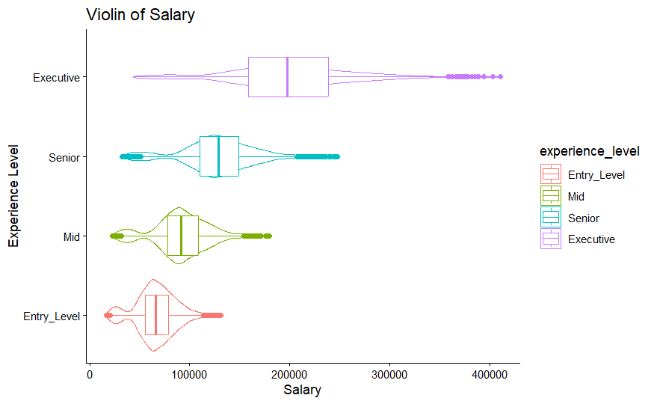
The distributions among industries also followed a similar pattern, but a few industries, such as Automotive, had slightly higher average salary than other levels. In addition, job titles showed a pattern similar to education. However, the clear differences appeared across experience levels. Executive group had the widest range and the highest values, whereas entry-level individuals clustered lower, with mid and senior level groups distributed in between.
Time line plots for skills and job titles showed that Python and SQL skill are the highest demand skills from 2024 to 2025. However, Job title trends appeared more discrete and did not show a clear pattern.
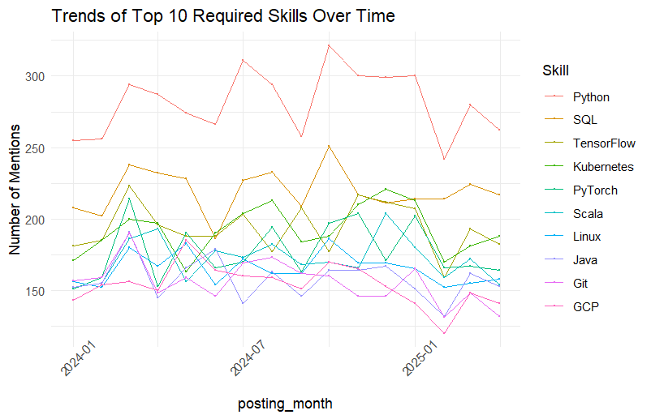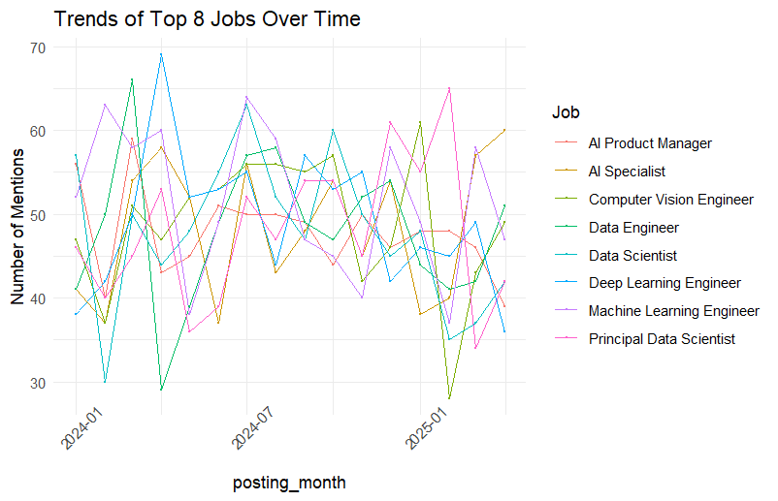
3.2 Mixed-Effects Model Results
To explore the group-level variation, we fitted a linear mixed-effects model using company location and experience level as random intercepts. ICC values revealed that these two factors explained the meaning of between-group variation (0.37 for company location and 0.58 for experience level).
GRP | Var | SD | ICC
company_location | 0.139 | 0.373 | 0.368
experience_level | 0.219 | 0.467 | 0.579
Residual | 0.0197 | 0.141 | 0.052
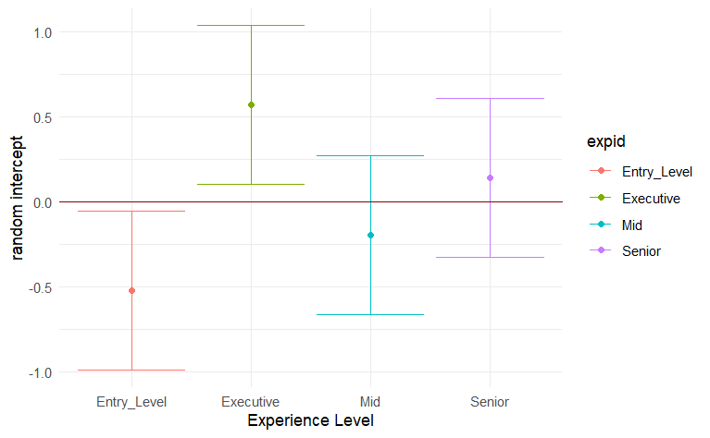
Error-bar plots of the random effects showed that experience levels differed substantially. Entry-level positions tended to fall below the 0 line, whereas executive roles were clearly above it. For company location, most countries were clustered near zero, but a few countries such as China and India, were lower, while Denmark, Norway, and the US were higher.
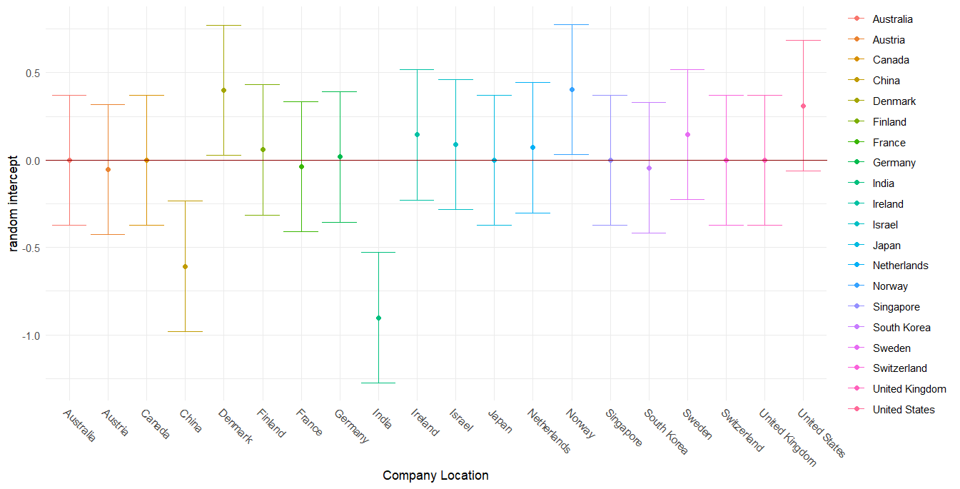
The fixed-effects estimates suggested that employment type had a small impact on salary, like freelancers and full-time employees earning more on average. Several employee residence countries showed negative coefficients after controlling for other variables, , such as Italy, France, Singapore, and Norway. Industry also existed some effects, with the technology industry paying slightly more. The strongest fixed effect in the model came from company size: salaries in medium and small companies were significantly lower than in large companies.
On the other hand, many variables were not statistically significant. Most job titles had coefficients close to zero, and education requirements (Bachelor, Master, PhD) also showed tiny impact. Skill indicators were not significant. Besides, variables such as company name, remote ratio, and currency type also did not show meaningful influence in the final model.
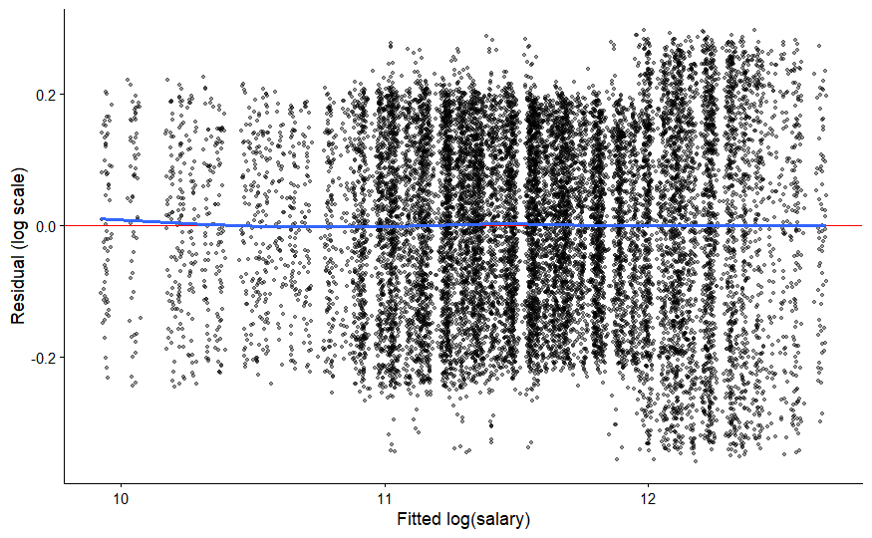
However, the variance is not ideal. When the fitted log(salary) is below 11, the residuals mostly fall within the range of –0.2 to 0.2. In contrast, the right side of the plot shows a wider distribution, exceeding 0.2.
- Discussion
The mixed-effects structure reveals strong group-level patterns. Experience level and company location explain 58% and 37% of the total variation, while the residual variance is only 5%. This indicates that salary differences are largely structured by group membership rather than individual identity. However, experience level only contains four categories, which may cause large within-group variation.
Besides, the analysis shows that company size plays an important role in salary differences. Medium-sized and small companies offer lower payment than large companies. This suggests that large companies generally have stronger financial capacity.
In contrast, the effects of skills and education were weak. Most skill indicators and education levels had coefficients close to zero and were not statistically significant , likely because they represent binary entry requirements, without skill level. The skill variables do not capture capacity differences because skills were counted only as binary indicators or simple totals For example, program means whether master the programming skill, so it may overlook meaningful details.
Some variables had small but significant effects. Employees in the technology industry earned slightly higher salaries, and freelancers or full-time workers showed minor positive effects as well. However, these effects are relatively small compared to the influence of company size and experience level.
This study exists some limitation. First, job title, and skill variables are likely correlated. Then, employee residence and company location may be be same, which causes correlation. Besides, the skill indicators just means whether owning the skills, without the level of skills, which might reduce the effect of skills on salary. In addition, this data use synthetic data, might cause residual very small.
Future analysis will expands the sample size and incorporates multi-year data to improve the stability of the estimates. In additional, the model results can provide practical guidance for employers and job seekers. Future work could explore how salary gaps between large and small companies arise and identify whether skills contribute to salary growth.
Overall, the findings indicate that company size and group-level variables, (experience level and company location), are the dominant factors influencing salary in the Data Science job market. Many individual skills or education levels do not show strong effects. From my perspective, choosing a larger company, working in a higher-paying region, or advancing to a higher experience level is likely to gain more salary than adding more skills or degrees.
Appendix
Unveiling Data Scientist Salaries: Predictive Modeling for Compensation Trends
https://www.jcbi.org/index.php/Main/article/view/882

Statistic Value | salary_usd | years_experience | benefits_score
Min | 16,621 | 0.000 | 5.0
1stQu. | 74,979 | 2.000 | 6.3
Median | 107,262 | 5.000 | 7.5
Mean | 121,992 | 6.366 | 7.5
3rdQu. | 155,752 | 10.000 | 8.8
Max | 410,273 | 19.000 | 10.0
The summary of continuous variable
Variable |  | Estimate | Std.Error | T value
employment_type | Freelancer | 0.007329 | 0.003252 | 2.254
employment_type | Full Time | 0.006544 | 0.003251 | 2.013
employee_residence | Czech Republic | -0.04981 | 0.02036 | -2.447
employee_residence | France | -0.03857 | 0.01639 | -2.353
employee_residence | Israel | -0.03550 | 0.01642 | -2.162
employee_residence | Italy | -0.05346 | 0.02082 | -2.568
employee_residence | Singapore | -0.04251 | 0.01638 | -2.595
industry | Technology | 0.01358 | 0.006272 | 2.166
company_size | M | -0.1436 | 0.002818 | -50.939
company_size | S | -0.2462 | 0.002815 | -87.458
The statistically significant variable
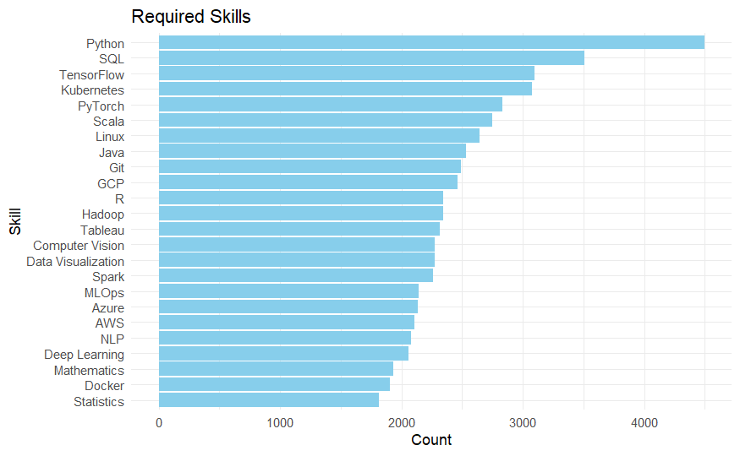
The bar plot of require skill
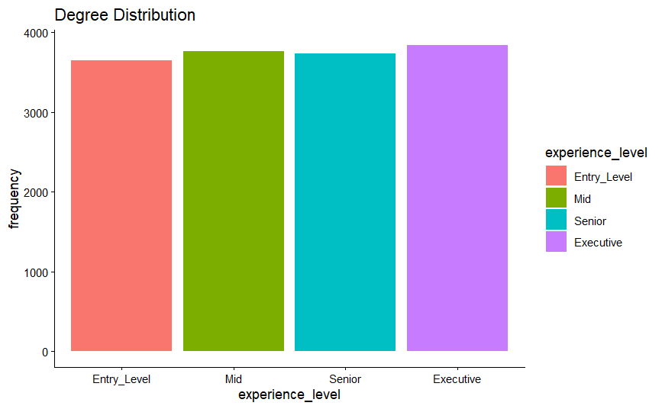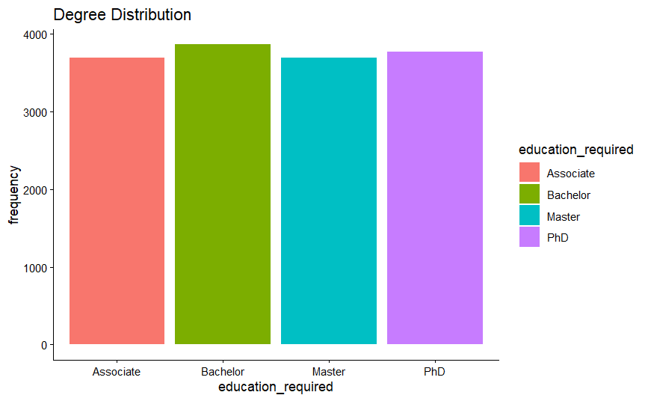
The distribution of education level The distribution of experience level
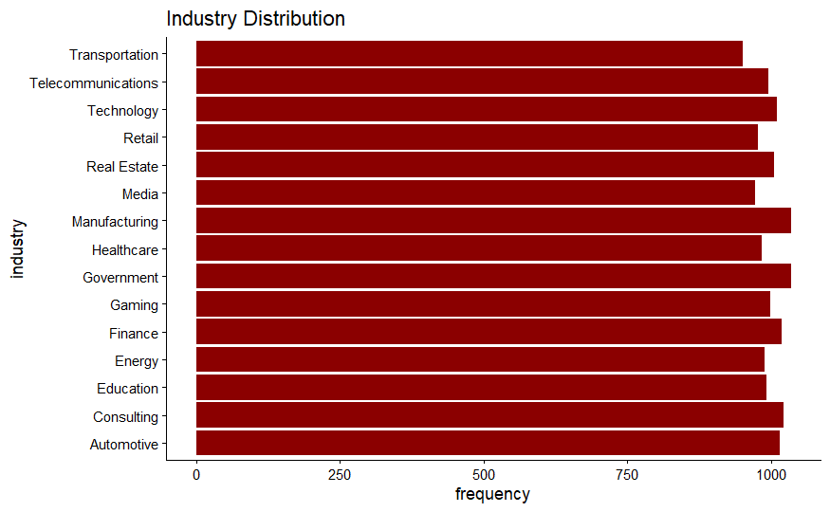
The job distribution in different industry
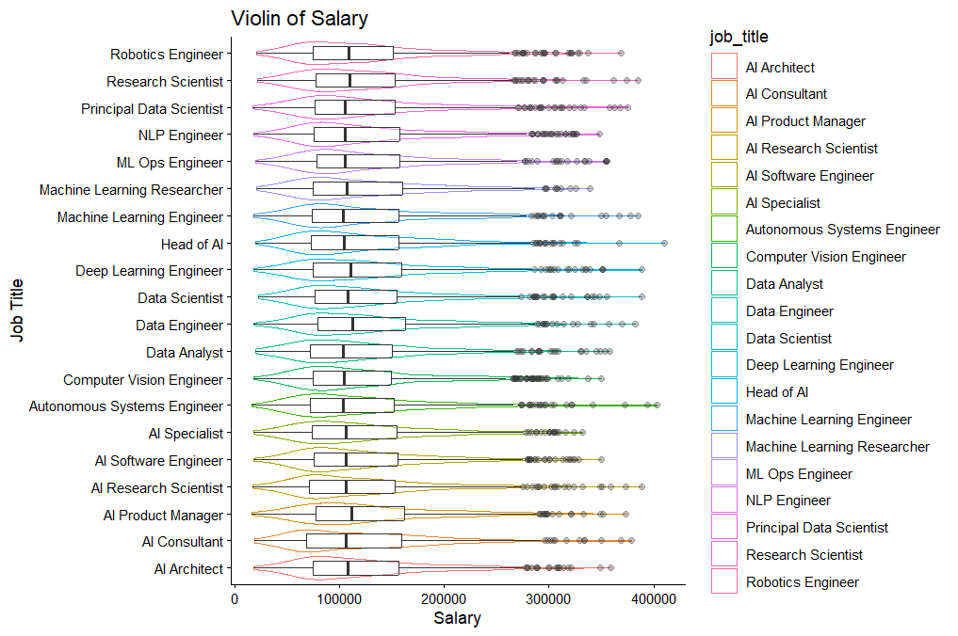
The salary distribution among different jobs
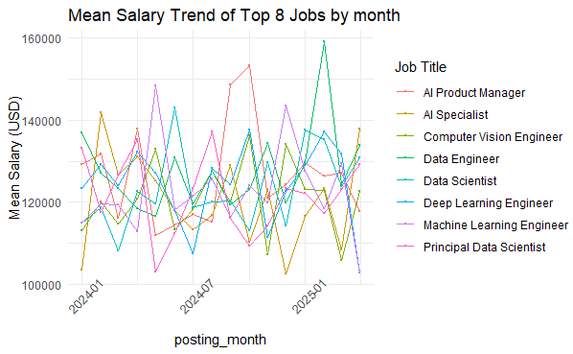
The average salary trend plot of different job
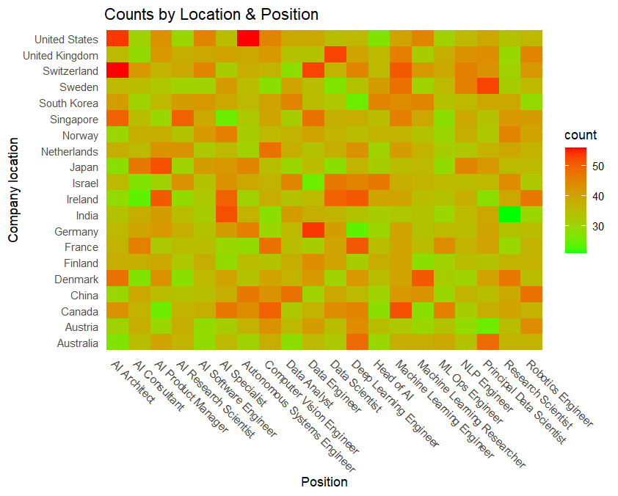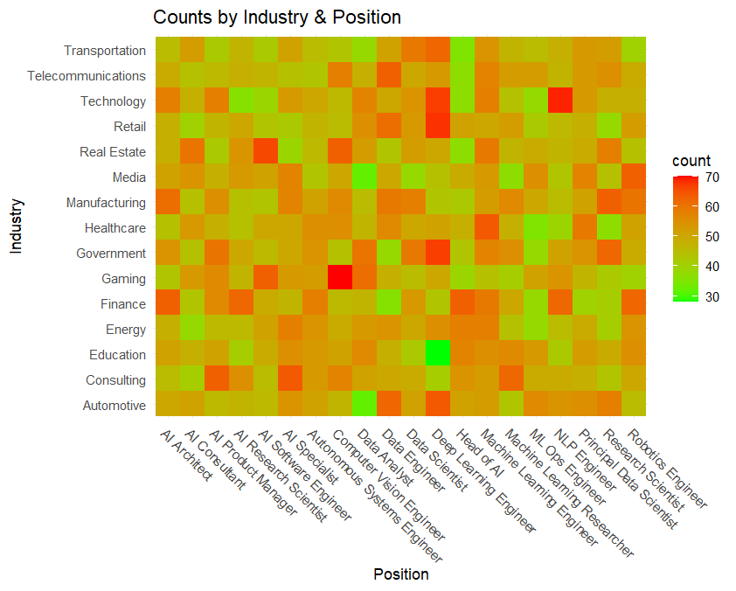
The job heat map in company location The job heat map in industry
Supplement
## Uploading Data
```{r}
salary2<-read.csv("ai_job_24_25.csv")
```
## Cleaning Data
```{r}
salary2<-salary2%>%
dplyr::select(-salary_local)
head(salary2)
```

```{r}
salary<- salary2
salary <- salary %>%
mutate(
experience_level = case_when(
experience_level %in% c("EN", "Entry_Level") ~ "Entry_Level",
experience_level %in% c("EX", "Executive") ~ "Executive",
experience_level %in% c("MI", "Mid") ~ "Mid",
experience_level %in% c("SE", "Senior") ~ "Senior",
TRUE ~ experience_level
),
employment_type = case_when(
employment_type %in% c("FT", "Full Time") ~ "Full Time",
employment_type %in% c("PT", "Part Time") ~ "Part Time",
employment_type %in% c("CT", "Contract") ~ "Contract",
employment_type %in% c("FL", "Freelancer") ~ "Freelancer",
TRUE ~ employment_type
))
salary<-salary%>%
mutate(posting_date = str_trim(posting_date),
posting_date=str_replace_all(posting_date,'/','-'),
posting_date = case_when(
str_detect(posting_date, "^\\d{1,2}-\\d{1,2}-\\d{2}$") ~ as.Date(posting_date, format = "%m-%d-%y"),
str_detect(posting_date, "^\\d{4}-\\d{1,2}-\\d{1,2}$") ~ as.Date(posting_date, format = "%Y-%m-%d"),
TRUE ~ NA_Date_
),
application_deadline=as.Date(application_deadline)
)
salary<-salary%>%
filter(year(posting_date)>2023)
```

```{r}
salary_long<-salary%>%
separate_rows(required_skills, sep = ",\\s*")
salary_wide<-salary_long%>%
mutate(value=1)%>%
pivot_wider(names_from = required_skills,
values_from = value,
values_fill = 0 )
group_map <- list(
Program= c("Java","R","Python","Scala"),
Version = c("Git","Linux"),
BigData= c("Hadoop","Spark","SQL"),
Cloud= c("GCP","AWS","Azure"),
Deployment= c("Docker","Kubernetes","MLOps"),
ML_Frameworks= c("TensorFlow","PyTorch"),
ML_Tasks= c("Deep Learning","Computer Vision","NLP"),
Visual= c("Tableau","Data Visualization"),
Stats_Math= c("Statistics","Mathematics")
)
salary_wide <- salary_wide %>%
mutate(
program = if_else(Java == 1 | R == 1 | Python == 1 | Scala == 1, 1, 0),
version = if_else(Git == 1 | Linux == 1, 1, 0),
bigdata = if_else(Hadoop == 1 | Spark == 1 | SQL == 1, 1, 0),
cloud = if_else(GCP == 1 | AWS == 1 | Azure == 1, 1, 0),
deployment = if_else(Docker == 1 | Kubernetes == 1 | MLOps == 1, 1, 0),
MLprogram = if_else(TensorFlow == 1 | PyTorch == 1 | Python == 1, 1, 0),
MLKnowledge = if_else(`Deep Learning` == 1 | NLP == 1 | `Computer Vision` == 1, 1, 0),
math = if_else(Mathematics == 1 | Statistics == 1, 1, 0)
)%>%
arrange(posting_date) %>%
mutate(time_index = as.numeric(factor(format(posting_date, "%Y-%m"))))
summary(salary_wide)
```
```{r}
##removing job_id, job_description_length, application_deadline, index_time
fit1<-lmer(log(salary_usd)~job_title+years_experience+ employment_type+employee_residence+ education_required + remote_ratio+ industry +company_size+ salary_currency+program+ version+ bigdata+ cloud+ deployment+ MLprogram+ MLKnowledge+math+ (1|experience_level)+(1|company_location ),data=salary_wide)
vc1 <- as.data.frame(VarCorr(fit1))
vc1
```

```{r}
icc_cal<-function(fit=fit1, name = "Residual"){
vc <- as.data.frame(VarCorr(fit))
total_var <- sum(vc$vcov, na.rm = TRUE)
sigma2_group <- vc$vcov[vc$grp == name]
icc_value <- sigma2_group / total_var
return(icc_value)
}
icc_cal(fit1)
```

